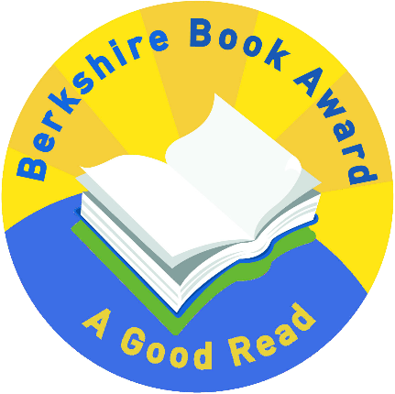
Berkshire Book Award 2021 – Longlist title
The Kid Who Came From Space by Ross Welford

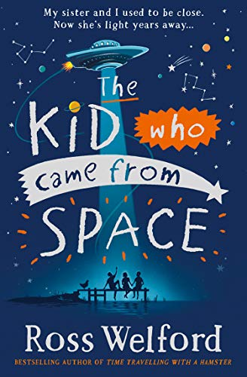
A small village in the wilds of Northumberland is rocked by the disappearance of twelve-year-old Tammy. Only her twin brother, Ethan, knows she is safe – and the extraordinary truth of where she is. It is a secret he must keep, or risk never seeing her again.
But that doesn’t mean he’s going to give up.
Together with his friend Iggy and the mysterious (and very hairy) Hellyann, Ethan teams up with a spaceship called Philip, and Suzy the trained chicken, for a nail-biting chase to get his sister back…that will take him further than anyone has ever been before.

Discussion questions
Do you think aliens exist? Why or why not?
What do you think are the things that make us human? What defines us/you?
Hellyann come from the planet Anthalla, where they do not show emotions. Do you think society is better with or without displaying feelings and why?
Tammy was kept in a 'human zoo' on Anthalla. Does this make you think differently about zoos we have on Earth or are they not the same?
The book uses newspaper articles to tell parts of the narrative, do you like this method of storytelling? Did you find it helpful or a hindrance to the story?
What do you think about the characters Geoff Jr and Geoff Snr?

